Diagnostic accuracy of salivary microRNAs for detecting oral squamous cell carcinoma: A systematic review and meta-analysis

ABSTRACT
Background: Salivary microRNAs have been investigated as noninvasive biomarkers for oral squamous cell carcinoma (OSCC), but their diagnostic performance and clinical applicability remain uncertain. This review evaluated their diagnostic accuracy in detecting OSCC.
Methods: PubMed, Scopus, ScienceDirect, and Google Scholar were searched from database inception through July 2026. Primary human diagnostic studies evaluating salivary microRNAs against histopathologic confirmation were eligible. Risk of bias and applicability were assessed using QUADAS-3. Random-effects synthesis of log diagnostic odds ratios, pooled sensitivity and specificity, and an exploratory SROC analysis were conducted in JASP. A hierarchical bivariate/HSROC model was unavailable; therefore, estimates were interpreted as exploratory. Sensitivity analyses excluded zero-cell studies and examined healthy-control, panel, derivation, and validation cohorts. The review was not prospectively registered.
Results: Ten studies met the review criteria, and seven studies comprising 220 OSCC and 235 comparator observations entered quantitative synthesis. Pooled sensitivity was 0.891 (95% CI, 0.842–0.926), specificity was 0.849 (95% CI, 0.729–0.922), LR+ was 5.90 (95% CI, 3.15–11.06), LR− was 0.128 (95% CI, 0.087–0.191), and DOR was 40.89 (95% CI, 14.67–114.00). Exploratory SROC AUC was 0.935 (95% CI, 0.885–0.965). Heterogeneity was low to moderate (I² = 34.46%). Excluding zero-cell studies did not change the direction of findings. Most studies used case-control designs with healthy controls, and overall certainty was very low.
Conclusion: Salivary microRNAs showed promising exploratory diagnostic discrimination for OSCC, but current evidence does not establish screening or routine clinical utility. Prospective validation using clinical controls, standardized assays, and separately reported stage I–II disease is required.
Keywords: Carcinoma, Squamous Cell; MicroRNAs; Mouth Neoplasms; Saliva; Sensitivity and Specificity.

INTRODUCTION
Lip and oral cavity cancer remains a major global health problem, with a substantial burden of morbidity and mortality. Data from the Global Cancer Observatory indicate that approximately 452,205 new cases and 194,108 deaths attributable to lip and oral cavity cancer occurred worldwide in 2024. Oral squamous cell carcinoma (OSCC) accounts for approximately 90% of malignancies arising in the oral cavity, while the five-year survival rate remains approximately 50%, primarily because many patients are diagnosed only after the disease has progressed to a more advanced stage. These conditions highlight the need to strengthen diagnostic pathways that can facilitate more accurate recognition of malignancy and accelerate patient referral for definitive examination.^{1–3}
The diagnosis of OSCC currently begins with a clinical examination of the oral cavity and is subsequently confirmed through biopsy and histopathological examination. Histopathology remains the reference standard because it can confirm the presence of malignant cells, determine the degree of differentiation, and identify tissue characteristics required for treatment planning. Nevertheless, biopsy is invasive, requires trained clinicians and pathologists, and represents only the specific portion of tissue that has been sampled. These limitations support the development of noninvasive examinations as adjunctive tools for triage and biopsy prioritization rather than as substitutes for histopathological examination. Therefore, the clinical utility of a biomarker should be assessed according to its ability to distinguish OSCC within populations that resemble real-world healthcare settings.^{3,4}
Saliva is a potentially valuable source of liquid biopsy material because it can be collected easily and repeatedly without causing tissue injury and is in direct contact with the mucosal surfaces where OSCC develops. Saliva contains various molecular components, including DNA, RNA, proteins, cytokines, and extracellular vesicles, which may reflect tumor-related biological alterations. One of the most extensively investigated components is microRNA (miRNA), a class of noncoding RNA approximately 19–24 nucleotides in length that regulates gene expression at the post-transcriptional level. MiRNAs can be released into saliva through extracellular vesicles or remain bound to proteins and lipids, thereby providing relative protection against enzymatic degradation. These characteristics allow salivary miRNAs to be analyzed using RT-qPCR, microarray, or sequencing technologies. However, their diagnostic performance may be influenced by saliva collection and processing procedures, the type of salivary fraction used, extraction techniques, normalization genes, analytical platforms, and the determination of positive cutoff values.^{3,4}
The selection of comparator groups is a critical issue when evaluating the diagnostic accuracy of salivary miRNAs. Most primary studies have employed case–control designs comparing patients with confirmed OSCC with healthy individuals. However, the ability to distinguish OSCC from healthy controls is not equivalent to the ability to distinguish OSCC from oral potentially malignant disorders (OPMDs), oral lichen planus, inflammatory conditions, infections, or benign oral lesions that may clinically resemble malignancy. Balakittnen et al. demonstrated that the performance of miRNA panels changed when patients with OSCC were compared with those with OPMDs rather than with healthy controls.3 The use of control groups that differ substantially from patients with OSCC may produce higher estimates of diagnostic accuracy than would likely be achieved in clinical practice. Therefore, the type of comparator should be considered a potential source of indirectness and spectrum bias and should be analyzed separately whenever sufficient data are available.^{3,5,6}
Several previous reviews have evaluated salivary biomarkers for the diagnosis of oral cancer, but important limitations remain regarding research questions specifically focused on salivary miRNAs. Liu et al. combined studies investigating miRNAs derived from both blood and saliva,⁵ whereas Bastías et al. mapped various types of salivary biomarkers through an exploratory systematic review.⁷ Qin et al. provided a narrative overview of developments in salivary miRNAs and cytokines,⁴ but did not pool sensitivity and specificity estimates using diagnostic test accuracy meta-analysis models. A recent meta-analysis by Wijaya et al. evaluated multiple classes of salivary biomarkers in OSCC,⁶ and therefore did not fully address the more specific question of miRNA performance according to comparator type, disease stage, salivary fraction, the use of individual biomarkers or panels, analytical methods, and the risk of bias arising from study design.
In response to these gaps, the present study aims to evaluate and synthesize the diagnostic accuracy or discriminatory ability of salivary miRNAs for detecting histopathologically confirmed OSCC. The primary outcomes will include sensitivity, specificity, positive likelihood ratio, negative likelihood ratio, diagnostic odds ratio, and the area under the summary receiver operating characteristic curve. Subgroup analyses are planned according to comparator group, disease stage when reported separately, salivary fraction, the use of a single miRNA or miRNA panel, analytical method, study design, and methodological quality. If sufficient data on stage I–II disease are unavailable, the conclusions will be restricted to the overall diagnostic accuracy of OSCC and will not be interpreted as evidence of readiness for population screening or clinical early detection.

RESEARCH METHODS
Research Design
This study employed a systematic review and meta-analysis design to evaluate the diagnostic accuracy of salivary microRNAs in distinguishing patients with oral squamous cell carcinoma (OSCC) from individuals without OSCC. Tests involving a single microRNA, microRNA panels, and exosomal microRNAs were considered the index tests, while histopathological diagnosis was used as the reference standard. Comparator groups were classified separately as healthy controls and clinical controls, including individuals with oral potentially malignant disorders (OPMDs), oral lichen planus (OLP), benign lesions, or inflammatory oral conditions, because the discriminatory performance of the tests may differ across these groups. The quantitative synthesis included only studies that directly reported a 2 × 2 diagnostic table or provided sufficient information to reconstruct such a table with certainty. Studies with insufficient diagnostic data were presented through narrative synthesis. Given the variations in biomarkers, saliva types, testing methods, threshold values, comparator groups, and validation stages, the pooled analysis was treated as an exploratory pooled analysis. Separate analyses were conducted according to control type, biomarker format, saliva fraction, analytical platform, and derivation or validation cohort status. Analyses of early-stage disease were performed only when data for stages I–II were reported separately.
Protocol and Reporting Guidelines
The study was reported in accordance with the Preferred Reporting Items for a Systematic Review and Meta-analysis of Diagnostic Test Accuracy Studies (PRISMA-DTA). The abstract was prepared according to PRISMA-DTA for Abstracts, while the reporting of the search strategy followed PRISMA-S. The structure of the study selection diagram was based on the PRISMA 2020 flow diagram, with adaptations for diagnostic accuracy studies. PRISMA-DTA was specifically developed to improve the transparency, reproducibility, and assessment of the validity and applicability of systematic reviews of diagnostic accuracy. PRISMA-S complements these reporting guidelines by providing detailed requirements concerning search strategies, search dates, databases, search restrictions, and record-management procedures.
Research Stages
The research process began with the formulation of a diagnostic accuracy research question and the specification of the population, index test, comparator groups, reference standard, and diagnostic outcomes. A research protocol was subsequently developed, followed by the construction of a search strategy for each database. Searches were conducted in the main databases and additional sources, after which duplicate records were removed. The remaining articles underwent title and abstract screening, followed by full-text eligibility assessment. Each excluded article was documented together with one primary reason for exclusion.
Articles meeting the eligibility criteria subsequently underwent data extraction by two independent reviewers, assessment of potential cohort overlap, and evaluation of the risk of bias and applicability concerns. Studies were then assigned to either quantitative or narrative synthesis according to the completeness and validity of their diagnostic data. Analyses were conducted using JASP and included sensitivity and subgroup analyses. The final stage involved assessing the certainty of evidence and preparing the study findings in accordance with PRISMA-DTA guidelines.
Research Question Framework
The PICO framework was adapted for diagnostic accuracy questions by adding a reference-standard component. This framework was used to ensure that the population, test, comparator, diagnostic standard, and study outcomes were formulated consistently.
Table 1. Research Question Framework
Component | Description
P (Population) | Human patients with histopathologically confirmed OSCC, including early- and advanced-stage disease, who had not received treatment before saliva collection.
I (Index Test) | Testing of a single salivary microRNA, a panel of multiple microRNAs, or microRNAs derived from exosomes, whole saliva, or saliva supernatant using RT-qPCR, microarray, or small RNA sequencing.
C (Comparison) | Healthy controls and clinical controls without OSCC, including patients with OPMDs, OLP, benign oral lesions, or inflammatory oral conditions. Healthy controls and clinical controls were analysed separately.
R (Reference Standard) | Histopathological examination as the reference standard for confirming OSCC. The status of comparator groups was established through clinical examination, histopathological examination, or other diagnostic procedures described in the primary studies.
O (Outcome) | TP, FN, FP, TN, sensitivity, specificity, positive likelihood ratio, negative likelihood ratio, DOR, AUC, and other diagnostic measures reported by the primary studies.
The primary research question was as follows: How accurately can salivary microRNA testing distinguish patients with histopathologically confirmed OSCC from individuals without OSCC?
Separate synthesis questions were formulated as follows:
- OSCC compared with healthy controls;
- OSCC compared with clinical controls;
- a single microRNA compared with a panel of multiple microRNAs;
- whole saliva or saliva supernatant compared with salivary exosomes;
- RT-qPCR compared with microarray or sequencing; and
- derivation cohorts compared with validation cohorts.
Eligibility Criteria
Eligibility criteria were used to determine which articles could be included in the systematic review, quantitative synthesis, or narrative synthesis. Searches were conducted from database inception through July 2026, without language restrictions at the search stage. Articles published in languages other than English were still assessed when their titles or abstracts indicated potential relevance to the research question.
Table 2. Article Eligibility Criteria
Aspect | Inclusion Criteria | Exclusion Criteria
Study type | Primary research involving human participants. | Reviews, systematic reviews, meta-analyses, editorials, commentaries, letters to the editor, case reports, or conference abstracts without a full report.
Population | Studies involving patients with oral squamous cell carcinoma (OSCC). | Studies that did not involve patients with OSCC or investigated head and neck cancer without reporting OSCC data separately.
Test material | Studies using saliva, saliva supernatant, oral swirl, oral rinse, or salivary exosomes. | Studies using only serum, plasma, blood, or tissue without saliva testing.
Index test | Studies evaluating one or more salivary microRNAs as diagnostic tests. | Studies that did not evaluate microRNAs as the index test.
Reference standard | Studies using histopathological examination to confirm the diagnosis of OSCC. | Studies that did not use an adequate reference standard to confirm OSCC.
Comparator group | Studies with a comparator group without OSCC, including healthy or clinical controls. | Studies without a comparator group.
Diagnostic outcomes | Studies reporting a 2 × 2 table, sensitivity, specificity, AUC, ROC curve, or other diagnostic measures. | Studies addressing only prognosis, survival, treatment response, recurrence, tumour aggressiveness, or post-treatment monitoring without evaluating the ability to detect OSCC.
Report availability | Full reports that allowed assessment of the study design, participants, test procedures, and study findings. | Full reports that were unavailable or did not provide sufficient information for eligibility assessment.
Publication period | Studies published from database inception through the final search in July 2026. | No studies were excluded based on publication year as long as they were indexed within the database coverage period and met the other eligibility criteria.
Language | No language restrictions were applied during the search. Non-English articles were assessed when they potentially met the eligibility criteria. | Articles were excluded when their full content could not be adequately assessed.
Cohort overlap | Reports from the same cohort could be considered when they provided additional and independent diagnostic information. | Reports from the same cohort were excluded when they provided no additional information and created a risk of counting participants more than once.
Eligibility for quantitative synthesis | Studies directly reporting TP, FN, FP, and TN or allowing the reconstruction of one 2 × 2 table that was consistent with the number of participants and reported rounding precision. | Studies were excluded from the quantitative synthesis when TP, FN, FP, and TN could not be validly determined.
Eligibility for narrative synthesis | Articles meeting the substantive eligibility criteria but not providing a valid 2 × 2 table were retained in the narrative synthesis. | Articles were excluded entirely when they did not meet the substantive eligibility criteria.
Article Search Strategy
Searches were conducted in PubMed, Scopus, ScienceDirect, and Google Scholar from database inception through July 2026. Additional searches were performed through the reference lists of eligible articles, searches for articles citing the primary studies, publisher websites, PubMed Central, ClinicalTrials.gov, the WHO International Clinical Trials Registry Platform, medRxiv, and the Open Science Framework. These additional sources were used to identify missed articles, related reports, protocols, unpublished research, and potential cohort overlap.
The search strategy did not require the terms sensitivity, specificity, AUC, or diagnostic accuracy because overly restrictive diagnostic filters may result in relevant studies being missed. The main search components consisted of terms relating to OSCC, saliva, and microRNA. The complete search strategies, search dates, number of results, search restrictions, and syntax adaptations for each database are presented in Table S1.
PubMed
("Mouth Neoplasms"[Mesh] OR "Carcinoma, Squamous Cell"[Mesh] OR "oral squamous cell carcinoma"[Title/Abstract] OR OSCC[Title/Abstract] OR "oral cancer"[Title/Abstract]) AND ( "Saliva"[Mesh] OR saliv*[Title/Abstract] OR "oral rinse"[Title/Abstract] OR "oral swirl"[Title/Abstract] OR "oral swirls"[Title/Abstract] ) AND ( "MicroRNAs"[Mesh] OR microRNA*[Title/Abstract] OR miRNA*[Title/Abstract] OR "exosomal microRNA"[Title/Abstract] OR "exosomal microRNAs"[Title/Abstract] OR "exosomal miRNA"[Title/Abstract] OR "exosomal miRNAs"[Title/Abstract])
Scopus
TITLE-ABS-KEY( ("oral squamous cell carcinoma" OR OSCC OR "oral cancer") AND (saliva OR salivary OR "oral rinse" OR "oral swirl") AND (microRNA OR miRNA OR "exosomal microRNA" OR "exosomal miRNA"))
ScienceDirect
("oral squamous cell carcinoma" OR OSCC OR "oral cancer") AND (saliva OR salivary OR "oral rinse" OR "oral swirl") AND (microRNA OR miRNA OR "exosomal microRNA" OR "exosomal miRNA")
Google Scholar
"oral squamous cell carcinoma" saliva microRNA "oral cancer" "salivary miRNA" OSCC "salivary microRNA" OSCC "exosomal miRNA" saliva "oral potentially malignant disorders" salivary miRNA "oral lichen planus" salivary miRNA OSCC
Bidirectional citation searching was performed. Backward citation tracking involved examining the reference lists of all eligible articles and previous systematic reviews. Forward citation tracking was conducted by identifying articles that cited the primary studies. When a diagnostic report did not provide the required information, the corresponding author could be contacted to request a cross-tabulation or information regarding the validation group.
Article Selection
All search results were exported to reference-management software. Duplicate articles were identified based on DOI, PMID, title, author names, publication year, journal, volume, and page numbers. After automated duplicate removal, a manual examination was conducted to identify differences in title formatting, online-first and print versions, and multiple reports derived from the same cohort. Publications originating from similar cohorts were not automatically classified as duplicates when they evaluated different candidate microRNAs. However, their relationships were documented to prevent participants from being counted more than once in the primary analysis.
Article selection was performed independently by two reviewers through title and abstract screening, followed by full-text assessment. Disagreements were resolved through consensus or consultation with a third reviewer. Inter-reviewer agreement was reported using percentage agreement and Cohen’s kappa coefficient. Full-text articles were assigned one primary reason for exclusion, including an ineligible population, non-saliva test material, an index test other than microRNA, absence of a comparator group, an inappropriate reference standard, failure to report diagnostic outcomes, inability to separate OSCC data, secondary publication, duplicate cohort without additional information, or unavailability of the full report. All excluded articles and their reasons for exclusion are presented in Table S2. The numbers of records at each stage were aligned with the search log and reported consistently in the Abstract, Methods, Results, PRISMA flow diagram, and supplementary materials.
Data Extraction
Data were independently extracted by two reviewers using a previously piloted structured extraction form. The extracted data were compared, and any discrepancies were resolved through consensus or consultation with a third reviewer when agreement could not be reached. The extracted information included: (1) study identification and location; (2) study design, recruitment method, and recruitment period; (3) number and characteristics of patients with OSCC and comparator participants; (4) control type, diagnostic criteria, disease stage, and treatment status; (5) type and fraction of saliva, collection conditions, storage, and processing; (6) RNA extraction method, analytical platform, and normalisation procedure; (7) candidate microRNAs or microRNA panels and diagnostic thresholds;(8) derivation or validation cohort status; (9) AUC, confidence interval, sensitivity, specificity, TP, FN, FP, TN, LR+, and LR−; (10) source and method used to obtain the 2 × 2 table; and (11) potential participant overlap. Results involving healthy controls and clinical controls were extracted as separate estimates and were not combined.
TP, FN, FP, and TN values were used directly when reported in the article or supplementary materials. When these values were not presented, a 2 × 2 table was reconstructed only from the number of patients with OSCC, the number of comparator participants, sensitivity, and specificity at the reported threshold. The table was reconstructed by identifying all possible integer values that satisfied the following equations:
$$Sensitivity=\frac{TP}{TP+FN}$$
$$Specifity=\frac{TN}{TN+FP}$$
Every possible TP and TN value was matched against the number of patients, number of comparator participants, and the number of decimal places used to report sensitivity and specificity. A reconstructed 2 × 2 table was accepted when only one integer combination produced, after rounding, the same sensitivity and specificity as those reported in the article. When more than one combination was possible, the denominator was uncertain, or the results were inconsistent with the sample size, the study was not included in the quantitative synthesis. A 2 × 2 table was not reconstructed solely from the AUC, overall accuracy, Youden index, positive predictive value, negative predictive value, correlation, fold-change value, or a statement that a biomarker demonstrated very high performance. An AUC approaching 1.00 was also not interpreted as indicating perfect TP and TN values in the absence of a cross-tabulation or supporting participant-classification data.
Each reconstructed table was independently verified by two reviewers. Table S3 presents the study name, number of OSCC patients, number of controls, original sensitivity and specificity, threshold value, TP, FN, FP, TN, source page or table, method of data derivation, rounding rule, and cohort type.
Selection of Diagnostic Results
Each participant group contributed only one independent estimate to each synthesis question. When an article reported multiple candidates, panels, threshold values, or models, the selected result prioritised an external validation cohort, independent validation, internal validation, or the primary model prespecified in the study objectives and methods. Result selection was not based solely on the highest AUC, sensitivity, specificity, or Youden index. When the primary result could not be objectively identified, the article was included in the narrative synthesis. Derivation and validation cohorts were not combined, and the primary analysis prioritised validation cohorts.
Potential participant overlap was assessed according to similarities in the authors, research location, recruitment period, sample size, clinical characteristics, saliva collection methods, and cohort identity. When overlap could not be ruled out, only one report was included in the primary analysis. For Mehterov et al. and Romani et al.,^{8,9} the report containing validation estimates and a more certain 2 × 2 table was selected for the primary analysis, while the other report was included in the narrative synthesis and sensitivity analysis.
Risk of Bias and Applicability Assessment
The risk of bias and applicability concerns were assessed using QUADAS-3 for each diagnostic estimate across four principal domains: participants, index test, target condition, and analysis. An ideal study was considered one that: recruited participants consecutively or randomly; avoided an extreme case–control design; prespecified candidate biomarkers and threshold values before validation; implemented blinding between the index test and histopathological assessment; applied the same reference standard to all participants; included all participants in the analysis; adequately described missing data; used an independent validation cohort; and reported verifiable diagnostic data. Assessments were performed independently by two reviewers, and disagreements were resolved through consensus or consultation with a third reviewer. Studies judged to have a high risk of bias remained in the primary analysis, but their influence was examined through sensitivity analyses. The certainty of evidence was subsequently assessed using GRADE separately for comparisons between OSCC and healthy controls and between OSCC and clinical controls. The assessment considered risk of bias, indirectness, inconsistency, imprecision, and potential publication bias. The use of healthy controls in case–control designs, predominance of patients with advanced-stage disease, small numbers of studies, wide confidence intervals, and variations in threshold values were considered factors that could reduce the certainty and applicability of the evidence.
Assessment of the Certainty of Evidence
The certainty of evidence was assessed using the GRADE approach for diagnostic accuracy studies. Separate assessments were performed for comparisons between OSCC and healthy controls and comparisons between OSCC and clinical controls. The domains considered were risk of bias, indirectness, inconsistency, imprecision, and potential publication bias. The findings were presented in a Summary of Findings table. GRADE provides a systematic approach for assessing confidence in a body of evidence, including evidence concerning comparative test accuracy.
The use of healthy controls in case–control designs was specifically evaluated within the indirectness and spectrum-bias domains. Studies predominantly involving patients with advanced-stage OSCC were not considered directly representative of the test’s ability to detect stage I–II OSCC or to distinguish OSCC from clinically suspicious oral lesions. A small number of studies, wide confidence intervals, and variations in threshold values were considered within the imprecision and inconsistency domains.
Data Analysis
Quantitative analyses were conducted using JASP. The input data consisted of the study identifier, TP, FN, FP, TN, control type, biomarker format, saliva fraction, testing platform, derivation or validation status, logDOR, and the standard error of the logDOR. JASP accepts effect sizes and standard errors as analytical inputs and provides a random-effects model using the restricted maximum likelihood (REML) estimator.
The sensitivity and specificity of each study were calculated as follows:
$$Sensitivity=\frac{TP}{TP+FN}$$
$$Specifity=\frac{TN}{TN+FP}$$
The positive likelihood ratio and negative likelihood ratio were calculated using:
$$LR^{+}=\frac{Sensivity}{1-Specifity}$$
$$LR^{-}=\frac{1-Sensivity}{Specifity}$$
The DOR was calculated using:
$$DOR=\frac{TP×TN}{FP×FN}$$
The principal effect measure for quantitative synthesis was the logDOR:
$$log⁡(DOR)=ln\left(\frac{TP×TN}{FP×FN}\right)$$
The standard error of the logDOR was calculated as:
$$SE\left[\log\left(DOR\right)\right]=\sqrt{\frac{1}{TP}+\frac{1}{FN}+\frac{1}{FP}+\frac{1}{TN}}$$
The pooled logDOR was subsequently transformed back to the DOR scale using the exponential function. A random-effects model with the REML estimator was used because of differences among studies in participants, comparator groups, candidate microRNAs, testing platforms, saliva fractions, and threshold values. The findings were reported as the pooled DOR, 95% confidence interval, p-value, and 95% prediction interval when estimable. Heterogeneity was assessed using the Q statistic, I², τ, and τ². Sensitivity and specificity were analysed separately on the logit scale as supportive analyses. These findings were interpreted as exploratory estimates because separate analyses do not fully preserve the relationship between sensitivity, specificity, and variation in threshold values. AUC values were reported at the individual-study level and were not pooled into a single AUC value when the origin and uncertainty of the summary curve could not be established consistently. When a study contained a zero value in one or more cells, a continuity correction of 0.5 was added to all four cells of that study solely for calculating the logDOR and its standard error. The correction was not applied to studies without zero cells. The effect of the correction was examined by repeating the analysis after excluding all studies with one or more zero cells.
Small-Study Effects and Publication Bias
Small-study effects were assessed only when at least 10 independent estimates were available for a single synthesis question. When fewer studies were available, asymmetry testing was not performed because of its low statistical power. Potential publication bias was evaluated qualitatively according to study size, the presence of small studies reporting exceptionally high diagnostic performance, protocol availability, selective reporting of miRNA candidates, and the existence of unpublished studies. Conclusions regarding the presence or absence of publication bias were not based solely on the visual appearance of a funnel plot.
RESULTS
Study Selection Results
The search yielded 214 records from databases and additional sources. After five duplicate records were removed, 209 records underwent title and abstract screening. At this stage, 166 records were excluded because they did not meet the eligibility criteria regarding the population, test material, index test, study design, or diagnostic outcomes. Subsequently, 43 articles were assessed in full text, of which 33 were excluded based on one primary reason: six were review articles or meta-analyses without primary data, 10 had insufficient diagnostic data, five used specimens other than saliva, four did not report OSCC data separately, three focused on prognosis, two did not include an eligible comparator group, two used overlapping cohorts without independent information, and one was not published in a peer-reviewed journal.
Ten primary studies met the eligibility criteria for the systematic review. After verifying the validity of the 2 × 2 diagnostic tables and assessing potential participant overlap, seven studies were included in the quantitative synthesis, whereas three studies were presented through narrative synthesis. A complete list of the 33 excluded full-text articles and the corresponding reasons for exclusion should be provided in Table S2.
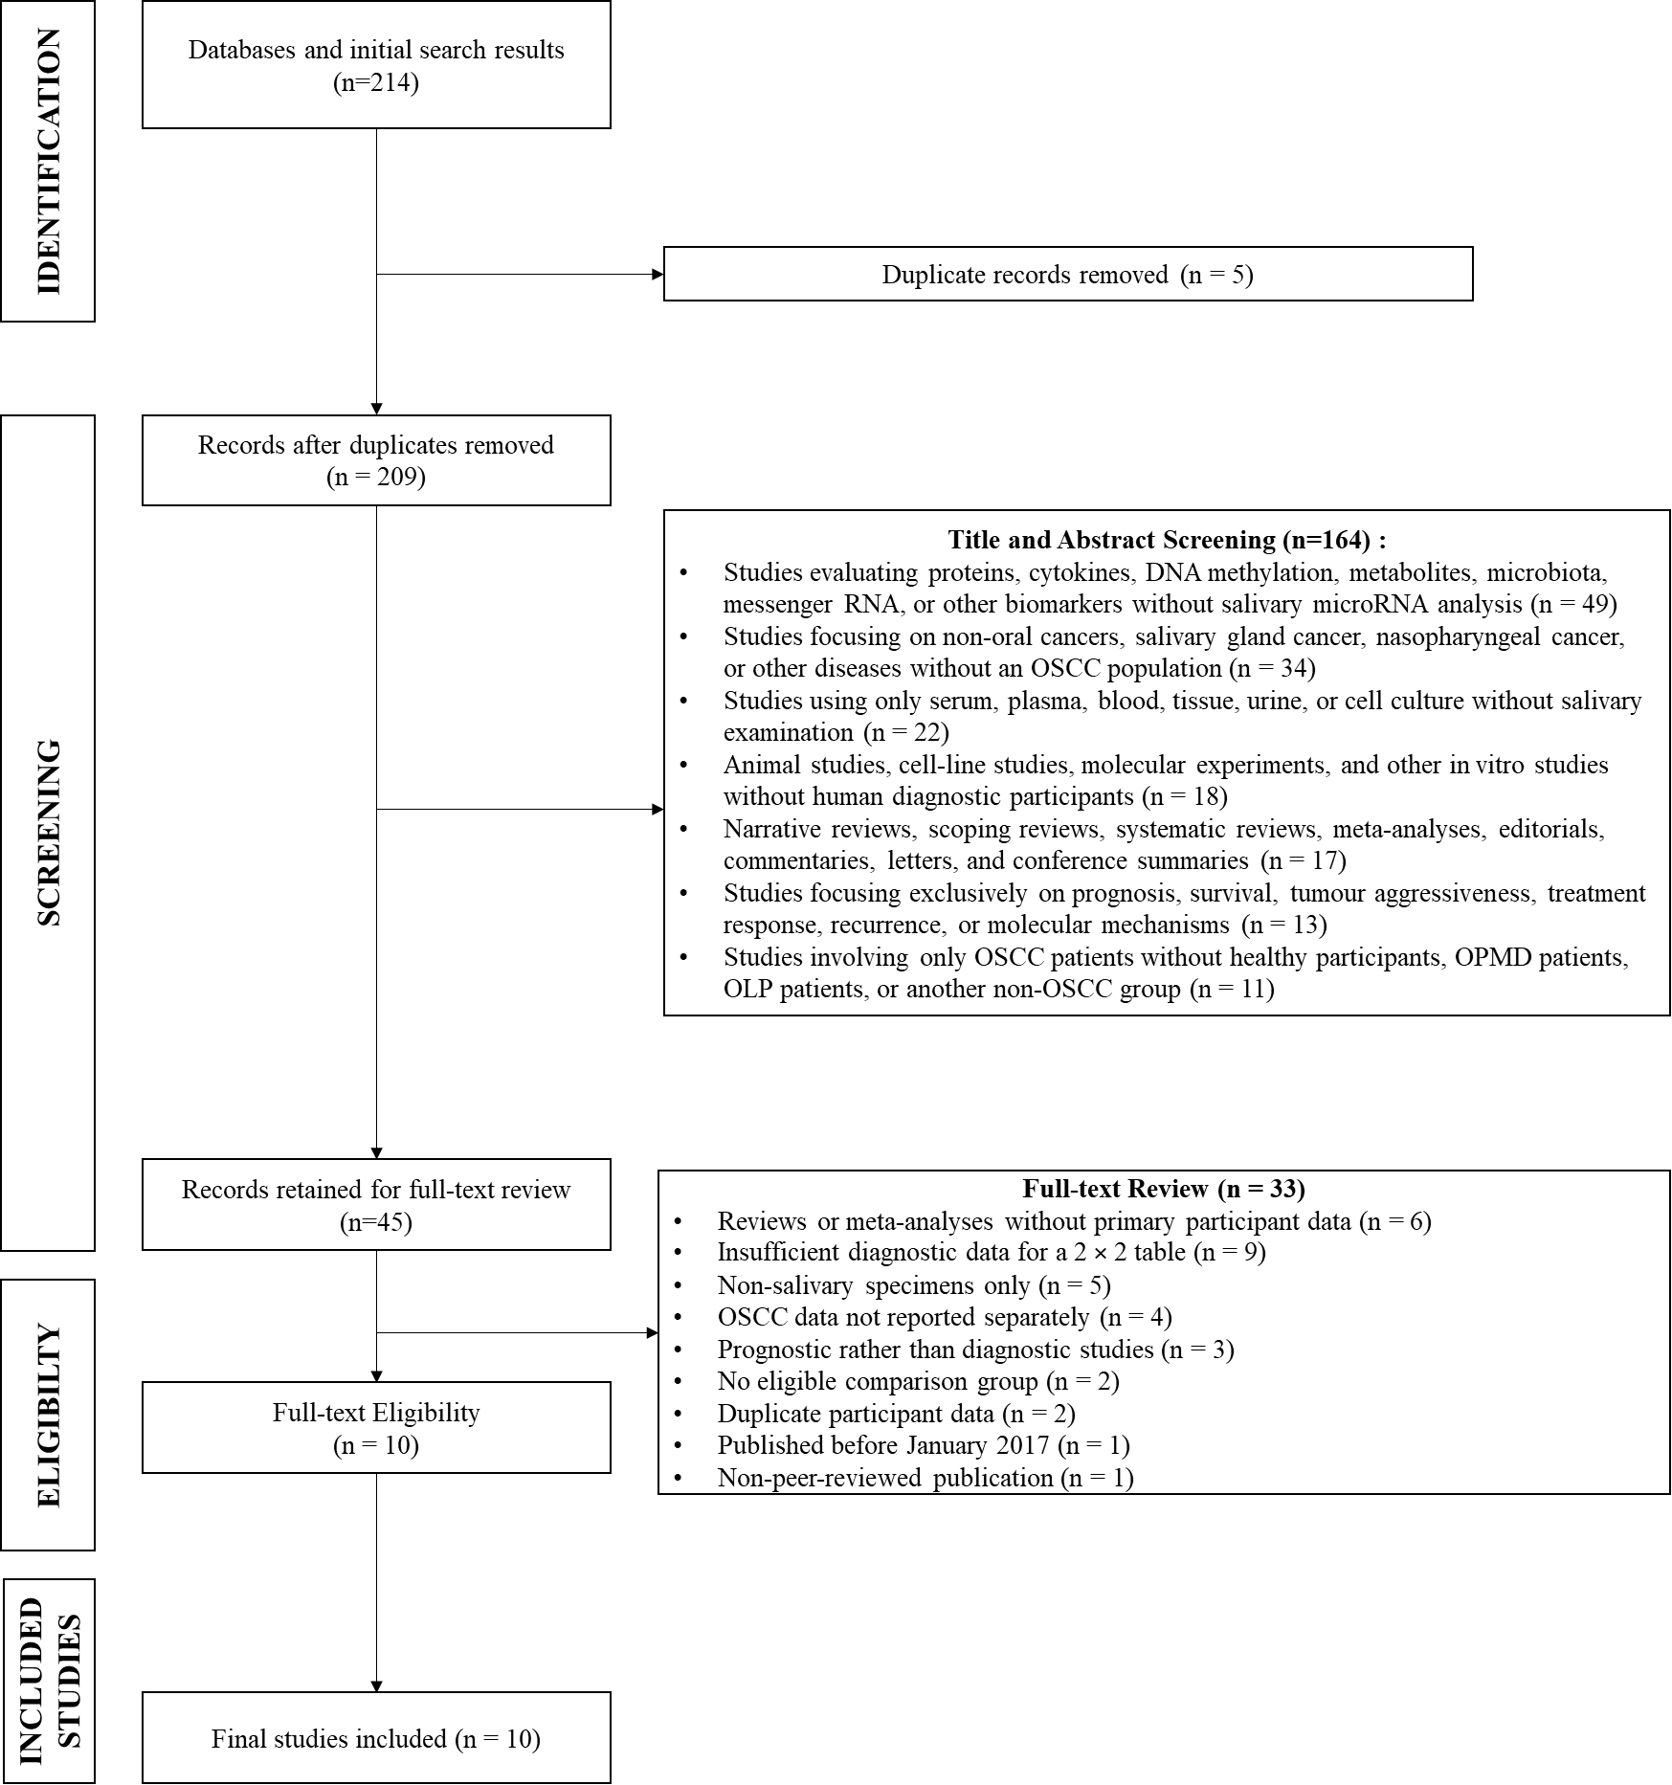
Figure 1. PRISMA Flow Diagram
Study Characteristics
The 10 eligible articles were published between 2018 and 2025. The studies were conducted in Australia, Italy, Bulgaria, Hungary, India, Egypt, and several collaborative research centers. Most studies used a case–control design or a diagnostic model development design involving patients with histopathologically confirmed OSCC and healthy individuals as comparators. Tarrad et al. included patients with OLP and healthy individuals,¹⁰ whereas Garg et al. and Balakittnen et al. also evaluated OPMD groups.^{3,11} Therefore, the available evidence predominantly reflects the ability to distinguish OSCC from healthy controls rather than the ability to differentiate OSCC from clinically similar oral lesions.
The studies varied in terms of OSCC stage, participant recruitment methods, saliva type and fraction, analytical methods, normalization procedures, microRNA candidates, threshold values, and model development stages. Some articles evaluated a single microRNA, whereas others used panels consisting of three to eight microRNAs. Most models remained at the derivation or internal validation stage, and only a few studies included a separate validation cohort. Details regarding country, design, setting, recruitment, disease stage, comparator type, saliva type, assay, normalizer, threshold value, and derivation or validation status are presented in Table 3.
Table 3. Study Inclusion in the Synthesis
No. | Study | OSCC (n) | Comparator (n) | Comparator | Status analisis
1 | Yap et al. (2018)¹² | 15 | 15 | Healthy controls | Quantitative
2 | Romani et al. (2021)⁹ | 83 | 53 | Healthy controls | Narrative
3 | Mehterov et al. (2021)⁸ | 50 | 42 | Healthy controls | Quantitative
4 | Patel et al. (2022)¹³ | 12 | 5 | Non-OSCC | Narrative
5 | Scholtz et al. (2022)¹⁴ | 43 | 44 | Healthy controls | Quantitative
6 | Tarrad et al. (2023)¹⁰ | 12 | 24 | OLP and healthy controls | Quantitative
7 | Garg et al. (2023)¹¹ | 30 | 60 | OPMD and healthy controls | Narrative
8 | Balakittnen et al. (2024)³ | 50 | 60 | Healthy controls | Quantitative
9 | ELHefny et al. (2024)¹⁵ | 20 | 20 | Healthy controls | Quantitative
10 | Ciringione et al. (2025)¹⁶ | 30 | 30 | Healthy controls | Quantitative
Study-Level Diagnostic Data
The seven studies included in the quantitative synthesis comprised 220 OSCC observations and 235 comparator observations. The diagnostic table for one study was obtained directly from the classification results of the test cohort, whereas the tables for the other six studies were reconstructed from the sample size, sensitivity, specificity, or outcome tables reported in the articles.¹² No additional data were included when the classification of true positives, false negatives, false positives, and true negatives could not be verified.
Three studies contained zero cells. Yap et al. and Tarrad et al. reported no false-negative cases,^{10,12} whereas ELHefny et al. reported neither false-negative nor false-positive cases.¹⁵ A continuity correction of 0.5 was applied to all four cells of these studies solely for the calculation of the log diagnostic odds ratio and its standard error. Its influence was examined through a sensitivity analysis excluding studies with zero cells.

Table 4. Diagnostic Results of Studies Included in the Quantitative Synthesis
Study | TP | FN | FP | TN | Sensitivity | Specificity | LR+ | LR− | logDOR (IK 95%) | Weight
Yap et al. (2018)¹² | 15 | 0 | 5 | 10 | 1,000 | 0,667 | 3,00 | 0,000 | 4,08 (1,08–7,08) | 5,9%
Mehterov et al. (2021)⁸ | 43 | 7 | 11 | 31 | 0,860 | 0,738 | 3,28 | 0,190 | 2,85 (1,80–3,91) | 26,3%
Scholtz et al. (2022)¹⁴ | 37 | 6 | 10 | 34 | 0,860 | 0,773 | 3,79 | 0,181 | 3,04 (1,93–4,16) | 24,9%
Tarrad et al. (2023)¹⁰ | 12 | 0 | 7 | 17 | 1,000 | 0,708 | 3,43 | 0,000 | 4,07 (1,11–7,02) | 6,0%
Balakittnen et al. (2024)³ | 43 | 7 | 6 | 54 | 0,860 | 0,900 | 8,60 | 0,156 | 4,01 (2,85–5,17) | 23,8%
ELHefny et al. (2024)¹⁵ | 20 | 0 | 0 | 20 | 1,000 | 1,000 | ∞ | 0,000 | 7,43 (3,46–11,39) | 3,5%
Ciringione et al. (2025)¹⁶ | 26 | 4 | 1 | 29 | 0,867 | 0,967 | 26,00 | 0,138 | 5,24 (2,98–7,49) | 9,6%

Pooled Diagnostic Accuracy
A random-effects analysis of the seven studies produced a pooled logDOR of 3.71, with a 95% CI of 2.69–4.74 and p < 0.001. After transformation, the pooled DOR was 40.89, with a 95% CI of 14.67–114.00. These findings indicate strong discriminatory ability. However, they should not be interpreted as the performance of a single specific clinical test because the estimate combines different microRNA candidates, panels, thresholds, saliva types, and validation stages.
The DOR prediction interval ranged from 6.93 to 241.12. This wide range indicates that future studies are still expected to demonstrate positive discriminatory ability, although the magnitude of performance may vary substantially according to participant characteristics, comparator groups, biomarkers, and analytical methods. Heterogeneity was low to moderate, with Q(6) = 9.15, p = 0.165, I² = 34.46%, and τ² = 0.301.
As an exploratory analysis, the pooled sensitivity was 0.891, with a 95% CI of 0.842–0.926, whereas the pooled specificity was 0.849, with a 95% CI of 0.729–0.922. The LR+ was 5.90, with a 95% CI of 3.15–11.06, and the LR− was 0.128, with a 95% CI of 0.087–0.191. The DOR derived from the pooled sensitivity and specificity was 45.90, with a 95% CI of 19.60–107.53. These estimates indicate that a positive result increases the likelihood of OSCC, whereas a negative result decreases it. However, the performance remains insufficient to support its use as a replacement for histopathology.
Paired Forest Plot
The paired forest plot showed that the sensitivity of the individual studies ranged from 0.860 to 1.000, whereas specificity ranged from 0.667 to 1.000. Studies with perfect sensitivity did not necessarily have correspondingly high specificity. Yap et al. and Tarrad et al. achieved a sensitivity of 1.000, but their specificities were only 0.667 and 0.708, respectively.^{10,12} In contrast, Ciringione et al. achieved a specificity of 0.967 with a sensitivity of 0.867.¹⁶
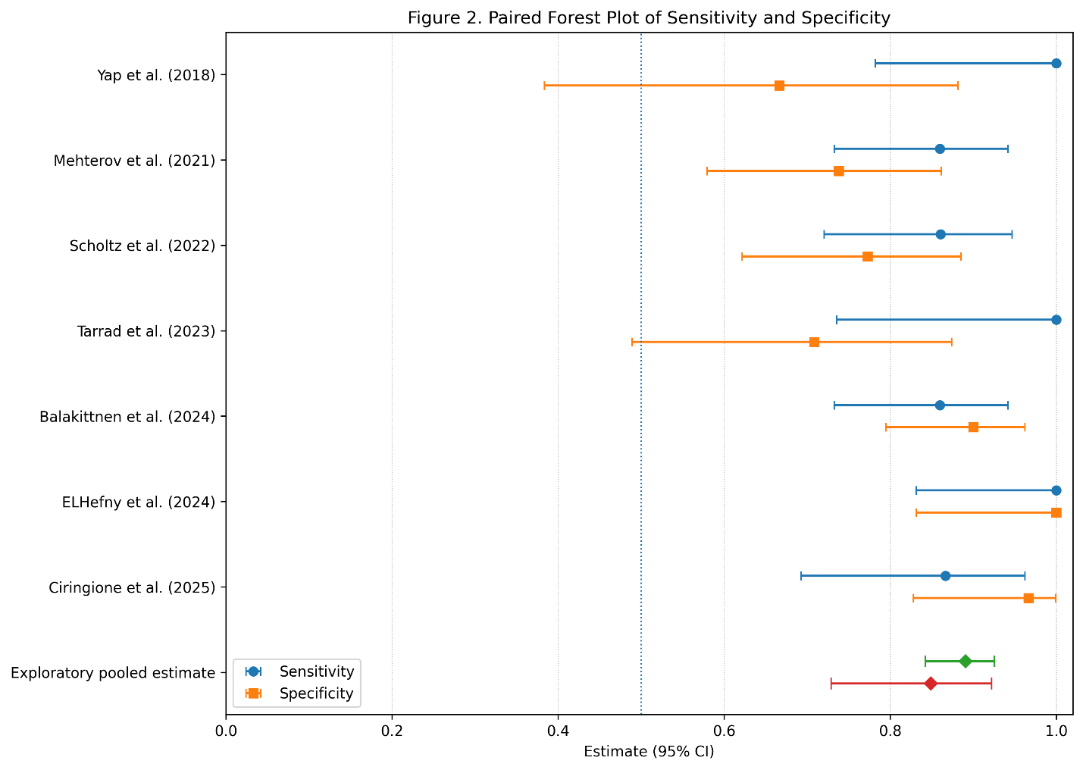
Figure 2. Paired Forest Plot of Sensitivity and Specificity
The confidence intervals were wider in studies with small sample sizes and zero cells. This was particularly evident in Yap et al. (2018),¹² Tarrad et al. (2023),¹⁰ and ELHefny et al. (2024).¹⁵ Therefore, perfect sensitivity or specificity values in these studies cannot be considered evidence that misclassification would not occur in a larger population.
SROC Curve
The exploratory SROC curve yielded an AUC of 0.935, with an estimated 95% CI of 0.885–0.965. The summary point corresponded to a sensitivity of 0.891 and a specificity of 0.849. This position indicates high overall discriminatory ability. However, the prediction region was wider than the confidence region, reflecting uncertainty regarding performance in new studies.
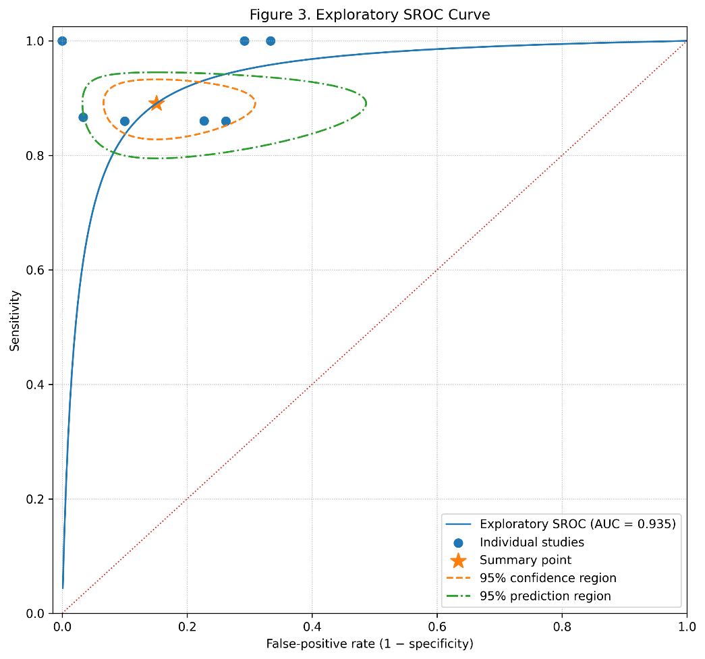
Figure 3. Exploratory SROC Curve
The curve was positioned as an exploratory analysis because it included only seven studies with different biomarkers, panels, comparator groups, and threshold values. Therefore, the pooled AUC does not represent a particular microRNA, panel, or diagnostic threshold. The prediction region should also be interpreted cautiously because the number of studies remains limited.
Sensitivity and Subgroup Analyses
Table 5. Sensitivity and Subgroup Analyses
Scenario | k | Sensitivity (IK 95%) | Specificity (IK 95%) | LR+ | LR− | DOR (IK 95%) | I²
Main analysis | 7 | 0,891 (0,842–0,926) | 0,849 (0,729–0,922) | 5,90 | 0,128 | 45,91 (19,60–107,53) | 34,5%
Excluding studies with zero cells | 4 | 0,861 (0,801–0,905) | 0,856 (0,738–0,926) | 5,96 | 0,162 | 36,78 (15,54–87,05) | 40,7%
Healthy controls only | 6 | 0,885 (0,834–0,921) | 0,870 (0,736–0,941) | 6,78 | 0,133 | 51,12 (19,36–134,97) | 44,6%
Multiple-miRNA panels | 4 | 0,877 (0,811–0,922) | 0,857 (0,723–0,932) | 6,11 | 0,144 | 42,50 (16,11–112,08) | 13,3%
Validation cohorts only | 3 | 0,878 (0,805–0,927) | 0,801 (0,660–0,893) | 4,42 | 0,152 | 29,06 (11,60–72,77) | 13,2%
Derivation cohorts only | 4 | 0,911 (0,758–0,971) | 0,909 (0,658–0,981) | 9,98 | 0,098 | 101,76 (13,46–769,37) | 54,3%
Excluding studies with zero cells reduced the DOR from 45.91 to 36.78 but did not change the direction of the conclusion. Therefore, the overall diagnostic effect was not determined entirely by studies reporting perfect classification. The analysis restricted to healthy controls produced a DOR of 51.12, whereas the analysis of multiple-microRNA panels produced a DOR of 42.50 with lower heterogeneity.
The performance of derivation cohorts appeared substantially higher than that of validation cohorts. The DOR in derivation cohorts reached 101.76, whereas it was only 29.06 in validation cohorts. The confidence interval for the derivation cohorts was also very wide, and heterogeneity was higher. This pattern indicates possible model optimism during the development stage. Therefore, findings from validation cohorts are more relevant for estimating the performance that may be achieved in new populations. A pooled analysis of single microRNAs was not retained because it comprised only three studies, two of which had zero cells. Comparisons involving clinical controls were also not pooled because the number of studies was insufficient and OLP, OPMD, and healthy controls could not be considered equivalent clinical spectra.
Risk of Bias and Applicability Concerns
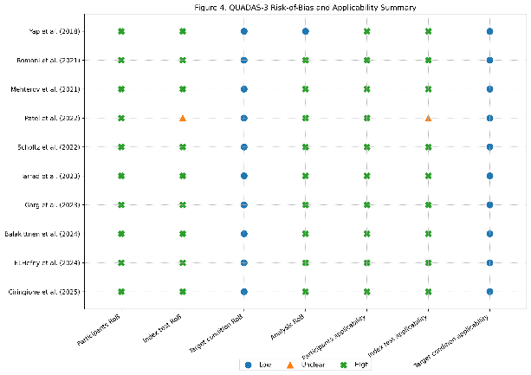 | 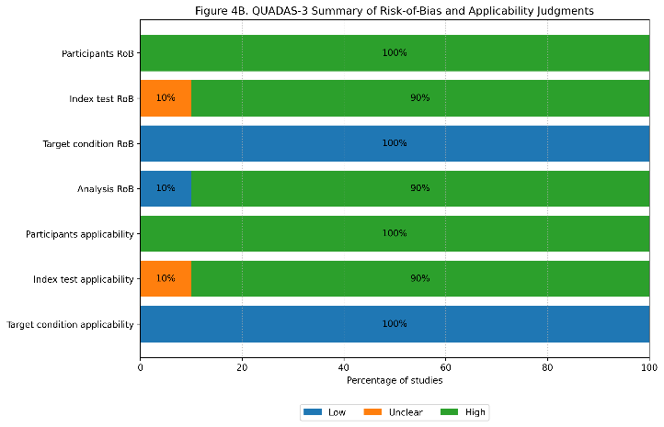
(a) | (b)
Figure 4. (a) QUADAS-3 Traffic-Light Plot; (b) QUADAS-3 Risk-of-Bias Summary
The QUADAS-3 assessment identified a high risk of bias in the participant-selection domain for all studies. This was mainly related to the use of case–control designs comparing patients with confirmed OSCC against healthy individuals rather than consecutively recruiting patients with clinically suspected oral lesions. The risk of bias in the index-test and analysis domains was also high in most articles because biomarker candidates, models, or threshold values were selected and tested in the same participant groups, while external validation remained limited.
The target-condition domain was generally judged to have a low risk of bias because OSCC diagnoses were confirmed by histopathology. Nevertheless, applicability concerns in the participant domain remained high because of the predominance of healthy controls and the inclusion of mixed disease stages. A sensitivity analysis excluding all studies at high risk of bias could not be conducted because every quantitative study had at least one domain judged to be at high risk.
Pooled Diagnostic Accuracy
The pooled analysis included seven studies that met the requirements for quantitative synthesis. A random-effects model was used because of differences in microRNA type, panel composition, comparator-group characteristics, analytical methods, threshold values, and model-development stages. The analysis produced estimates of sensitivity, specificity, likelihood ratios, logDOR, DOR, SROC AUC, prediction intervals, and between-study heterogeneity, as presented in Table 6.
Table 6. Pooled Diagnostic Accuracy of Salivary MicroRNA
Parameter | Estimate | 95% confidence interval
Number of studies | 7 | –
Pooled sensitivity | 0,891 | 0,842–0,926
Pooled specificity | 0,849 | 0,729–0,922
Positive likelihood ratio (LR+) | 5,90 | 3,15–11,06
Negative likelihood ratio (LR−) | 0,128 | 0,087–0,191
Pooled logDOR | 3,71 | 2,69–4,74
Pooled DOR | 40,89 | 14,67–114,00
Exploratory AUC SROC | 0,935 | 0,885–0,965
DOR prediction interval | – | 6,93–241,12
Cochran’s Q | 9,15 | df = 6; p = 0,165
I² | 34,46% | –
τ | 0,55 | –
τ² | 0,301 | –
Table 6 indicates that salivary microRNA has strong discriminatory ability for differentiating patients with OSCC from individuals without OSCC, as demonstrated by a pooled sensitivity of 89.1%, a specificity of 84.9%, and a DOR of 40.89. The LR+ of 5.90 indicates that a positive result increases the likelihood of OSCC, whereas the LR− of 0.128 indicates that a negative result may reduce the likelihood of disease, although it remains insufficient to replace histopathological confirmation. The SROC AUC of 0.935 also indicates high discriminatory performance. Heterogeneity was low to moderate, with I² = 34.46%, Q(6) = 9.15, and p = 0.165, whereas τ = 0.55 and τ² = 0.301 indicate that some between-study variation remained. The wide DOR prediction interval indicates that diagnostic accuracy in future studies may vary according to the biomarker candidate, comparator type, examination method, threshold value, and derivation or validation status of the cohort.

DISCUSSION
Diagnostic Accuracy of Salivary miRNA
The quantitative synthesis of seven studies yielded a pooled sensitivity of 0.891, specificity of 0.849, positive likelihood ratio (LR+) of 5.90, negative likelihood ratio (LR−) of 0.128, and an area under the summary receiver operating characteristic curve (SROC AUC) of 0.935. The pooled diagnostic odds ratio (DOR) of 40.89 indicates that the odds of obtaining a positive salivary microRNA test result were higher among participants with oral squamous cell carcinoma (OSCC) than among participants without OSCC. However, the DOR should not be interpreted as a risk ratio or as the probability that an individual has OSCC, because the clinical meaning of a test result remains dependent on the pretest probability of disease, the characteristics of the population, and the threshold applied. Statistical heterogeneity was low to moderate, with Q(6) = 9.15, p = 0.165, I² = 34.46%, τ = 0.55, and τ² = 0.301. Nevertheless, the wide DOR prediction interval of 6.93–241.12 indicates that diagnostic performance in future studies may vary substantially. Excluding studies with zero cells reduced the DOR to 36.78 but did not change the direction of the conclusion. Thus, the overall findings were not entirely driven by studies reporting perfect classification, although these small studies still increased the magnitude of the estimate and the uncertainty surrounding the results.
The pooled estimate should be regarded as an exploratory pooled analysis because the biomarkers included in the synthesis did not originate from an identical diagnostic test. The studies evaluated different individual microRNAs or panels, used varying types of saliva and processing methods, employed nonuniform analytical platforms, applied different thresholds, and included derivation and validation cohorts with nonequivalent characteristics. Therefore, the estimate reflects the general tendency of salivary microRNAs to discriminate between OSCC and non-OSCC conditions rather than the accuracy of a specific diagnostic product or panel.
Comparison with Previous Evidence
The pooled sensitivity and AUC estimates in the present study were higher than those reported in several previous meta-analyses. An earlier meta-analysis of salivary microRNAs for OSCC diagnosis reported a pooled sensitivity of approximately 0.70, specificity of 0.82, and AUC of 0.80.⁵ Another meta-analysis of salivary microRNAs for head and neck squamous cell carcinoma reported a sensitivity of 0.697, specificity of 0.868, AUC of 0.803, and DOR of 12.92.¹⁷ These differences may be related to the broader disease scope of the previous studies and the inclusion of more recent studies and high-performing panels in the present review.
A synthesis combining microRNAs derived from saliva and blood for oral and oropharyngeal cancers reported a sensitivity of 0.70, specificity of 0.75, DOR of 7, and AUC of 0.78.¹⁸ In contrast, the present study was restricted to OSCC and saliva and prioritised one principal estimate from each participant group. Differences in the target population, biofluid, model-selection rules, and composition of the comparator groups mean that the results of these meta-analyses cannot be compared directly. The higher values observed in the present study also do not indicate that the test is more ready for clinical implementation, particularly because most studies used case–control designs involving groups that were relatively easy to distinguish.
The literature on salivary biomarkers for oral cancer includes proteins, cytokines, RNA, DNA, metabolites, and biomarker combinations, with varying levels of methodological quality and validation.^{7,19} A meta-analysis covering several classes of salivary biomarkers reported a sensitivity of 0.64, specificity of 0.71, DOR of 4.53, and AUC of 0.75. It also showed that clinical usefulness was influenced by the baseline probability of OSCC in the population being tested.²⁰ These findings support the interpretation that the high performance reported in highly selected microRNA studies may not necessarily be replicated when the biomarkers are applied to a broader patient spectrum.
Influence of Comparator Group Type
The composition of the comparator groups represented one of the most important sources of indirectness in the present study. Six of the seven studies included in the quantitative synthesis used healthy controls as their primary comparator, whereas one study used a combined group of patients with oral lichen planus (OLP) and healthy individuals. The analysis restricted to healthy controls produced a sensitivity of 0.885, specificity of 0.870, and DOR of 51.12. These values primarily reflect the ability to distinguish patients with confirmed OSCC from individuals without oral lesions rather than the ability to identify OSCC among patients with leukoplakia, erythroplakia, OLP, inflammation, trauma, or other benign lesions.
Panel performance changed when OSCC was compared with oral potentially malignant disorders (OPMDs) rather than with healthy controls.³ High sensitivity in comparisons between OSCC and a combined group of patients with OLP and healthy individuals was also accompanied by lower specificity.¹⁰ In addition, microRNA expression patterns may overlap between OSCC and OPMDs, making it more difficult to distinguish these conditions than to distinguish OSCC from healthy individuals.¹¹ These findings indicate that clinical controls present a more realistic diagnostic challenge.
Studies of salivary biomarkers that included patients with OSCC, OLP, oral submucous fibrosis, and healthy controls demonstrated that biomarker performance may vary according to the disease spectrum being compared. Risk factors and the presence of OPMDs should be considered when evaluating salivary biomarkers because both may influence molecular expression and classification accuracy.²¹ The use of clinical comparator groups is also required to assess the ability of biomarkers to distinguish malignant conditions from premalignant and inflammatory lesions in a more representative manner.²² Therefore, the predominance of healthy controls in the included studies may have inflated estimates of sensitivity and specificity and limited their applicability to clinical practice.
Performance of Individual miRNAs and miRNA Panels
The subgroup analysis of four microRNA panel studies yielded a sensitivity of 0.877, specificity of 0.857, DOR of 42.50, and I² of 13.3%. The lower heterogeneity suggests that the panels evaluated in the selected studies tended to produce relatively balanced performance. From a biological perspective, the use of several microRNAs may capture multiple molecular pathways associated with proliferation, apoptosis, inflammation, invasion, and tumour responses, thereby potentially reducing dependence on a single marker. Combinations of several microRNAs have also frequently demonstrated greater discriminatory ability than individual candidates, although the compositions of the panels remain highly heterogeneous.^{4,23}
The apparent superiority of panels cannot yet be considered definitive because most models were developed and evaluated in the same participant groups. The analysis in the present study produced a DOR of 101.76 in derivation cohorts but only 29.06 in validation cohorts. This difference indicates model optimism resulting from the selection of candidates, coefficients, or thresholds that were tailored to the development data. Panels involving multiple candidates are also more susceptible to overfitting when developed using small samples. Conversely, the pooled analysis of individual microRNAs was not retained because only three studies were available, two of which contained zero cells. Current evidence is therefore insufficient to conclude that panels are consistently superior to individual microRNAs. Such comparisons should be conducted directly in the same participants using models and thresholds specified before validation.
Methodological Variability Across Studies
Conceptual heterogeneity among the included studies was greater than that reflected by the I² value. The examined specimens included oral swirl samples, whole saliva, salivary supernatant, and salivary exosomes. The analytical platforms included reverse transcription quantitative polymerase chain reaction (RT-qPCR), microarray analysis, and small RNA sequencing, accompanied by differences in RNA extraction methods, internal controls, and normalisation strategies. This lack of uniformity remains one of the major obstacles to comparing studies of salivary biomarkers.^{7,18}
Variations in fasting conditions, collection time, salivary stimulation, cellular contamination, centrifugation speed, storage temperature, freeze–thaw cycles, extraction methods, reverse-transcription efficiency, and normaliser selection may alter measured microRNA concentrations. Standardisation is required throughout all stages, including specimen selection, sample collection and storage, analytical procedures, and interpretation following normalisation.²⁴ In the included studies, the use of RNU6, SNORD60, reference microRNAs, or the mean of several controls indicates that relative expression was not reported using a common and readily comparable scale.
The exosome-based studies in the body of evidence were not included in the quantitative synthesis because their 2 × 2 diagnostic tables could not be adequately verified. Consequently, the pooled estimates predominantly represented microRNAs obtained from whole saliva, salivary supernatant, or oral swirl samples rather than the specific performance of exosomal microRNAs. Studies based on extracellular vesicles should transparently report the source material, preprocessing procedures, isolation methods, vesicle characterisation, non-vesicular contaminants, and analytical procedures in accordance with the MISEV2023 principles.²⁵ Incomplete reporting may result in variations in RNA concentrations and profiles that arise from procedural differences rather than biological differences related to disease.

Risk of Bias and Study Validity
The QUADAS-3 assessment identified a high risk of bias in the participant domain for all studies included in the quantitative analysis. This finding was primarily caused by the predominance of case–control designs in which patients with confirmed OSCC and healthy controls were recruited separately. The risk of bias in the index-test and analysis domains was also high in most studies because biomarker candidates, models, or thresholds were frequently determined using the same data employed to assess performance. The target-condition domain was comparatively stronger because OSCC diagnoses were generally confirmed through histopathological examination. Assessments of risk of bias and applicability should be performed for the selected diagnostic estimates and compared with an ideal study design aligned with the review question.²⁶
The difference between derivation and validation cohorts supports the findings of the risk-of-bias assessment. In addition, three studies contained zero cells, and several 2 × 2 tables were reconstructed from the reported sample sizes, sensitivities, and specificities. Although conservative reconstruction rules were applied, rounding in the primary articles may still have introduced uncertainty. Potential participant overlap between two publications was addressed by including only one report in the primary analysis. Nevertheless, cohort relatedness could not be entirely excluded on the basis of the available published information.^{8,9}
Using the GRADE approach for diagnostic accuracy, the overall certainty of evidence was rated as very low. The certainty was downgraded primarily because of a very serious risk of bias, indirectness resulting from the predominance of healthy controls and patients with confirmed OSCC, and imprecision resulting from the small number of studies, limited sample sizes, zero cells, and wide confidence and prediction intervals. Statistical inconsistency was not considered a major concern, although clinical and analytical heterogeneity should still be taken into account. Very low certainty of evidence does not mean that salivary microRNAs have no diagnostic value. Rather, it indicates limited confidence in the magnitude of the estimates and their applicability to clinical practice.¹⁷
Potential publication bias could not be adequately evaluated. A Deeks funnel plot was not constructed because only seven independent quantitative estimates were available. The absence of an asymmetry assessment cannot be interpreted as evidence that publication bias was absent. Small biomarker studies reporting negative findings or poor performance may be less likely to be published, whereas articles reporting high AUC values may be more widely represented in the literature.
Potential Clinical Application of miRNA
The LR+ of 5.90 indicates that a positive test result produces a meaningful increase in the probability of disease but is insufficient to establish a diagnosis independently. The LR− of 0.128 indicates that a negative result may reduce the probability of OSCC, although false-negative findings remain possible. The effects of these likelihood ratios on clinical decisions depend on the pretest probability of OSCC. In a general population with a low disease prevalence, the positive predictive value may remain low even when sensitivity and specificity appear favourable. Salivary biomarkers may therefore be more useful in populations enriched on the basis of symptoms or clinical findings than for general population screening.²⁰
The findings of the present study do not demonstrate a specific ability to detect stage I–II OSCC because early-stage disease was not reported separately and consistently. Most participants were patients who had already received an OSCC diagnosis and represented a mixture of early- and advanced-stage disease. The resulting estimates therefore reflect the general diagnostic discrimination of OSCC rather than screening performance or early detection among individuals without an established diagnosis. Longitudinal evidence regarding the ability of salivary microRNAs to predict malignant transformation in OPMDs also remains limited.²³
At the current stage of evidence, salivary microRNAs warrant further evaluation as adjunctive biomarkers for OSCC triage. Such tests cannot yet replace clinical evaluation, biopsy, or histopathological examination and are not ready to be recommended for routine clinical use. A potential role to be examined in future studies is assisting in the identification of patients with suspicious lesions who require more rapid referral or definitive testing rather than establishing the final diagnosis. These biomarker candidates still require broader standardisation and validation before they can be implemented in clinical services.⁴
Strengths and Limitations of the Study
The strengths of the present study include its specific restriction of the target disease to OSCC, the separation of healthy and clinical controls, and the distinction between quantitative and narrative synthesis. Each participant group contributed only one primary estimate, validation cohorts were prioritised over derivation cohorts, and two reports that potentially included the same participants were not included simultaneously in the primary analysis. The 2 × 2 tables were also verified against the source articles, and studies with data that could not be established with sufficient certainty were not forced into the quantitative synthesis. Sensitivity analyses excluding studies with zero cells and analyses according to comparator type, biomarker format, and validation status helped identify the sources of uncertainty in the findings.
The principal limitations of the present study were the scarcity of data specifically concerning stage I–II disease, the predominance of case–control designs, and the use of healthy controls that did not reflect the patient spectrum encountered in clinical practice. MicroRNA candidates, panel compositions, salivary fractions, analytical platforms, normalisers, and thresholds were also highly variable. Several 2 × 2 tables were derived from rounded sensitivity and specificity values, leaving the possibility of classification uncertainty. Three studies contained zero cells, and several models originated from small derivation cohorts. Potential cohort overlap could not be entirely excluded, whereas the number of studies was insufficient to evaluate small-study effects and publication bias. Certain subgroup analyses, particularly those involving clinical controls, individual microRNAs, and exosomal fractions, also failed to produce stable estimates because too few studies were available.

Implications for Future Research
Future research should employ prospective multicentre designs with consecutive participant recruitment from dental clinics, oral medicine clinics, or referral services. Study populations should consist of patients with oral lesions whose diagnoses are not yet known, while comparator groups should include OPMDs, OLP, inflammation, infection, trauma, and benign lesions. Outcomes for stage I–II OSCC should also be reported separately so that the ability of the test to identify disease at an early stage can be assessed directly.
MicroRNA candidates, panel compositions, algorithms, and thresholds should be specified before the validation cohort is analysed. Models should be locked and tested in external cohorts originating from different centres, time periods, and populations. Studies should also directly compare individual microRNAs and microRNA panels in the same participants rather than comparing performance estimates obtained from different studies. Reporting should include true positives, false negatives, false positives, and true negatives at each threshold, stage distributions, missing data, model calibration, and outcomes for all recruited participants.
Protocols for saliva collection and analysis should be standardised, including fasting conditions, collection time, stimulation, volume, centrifugation, storage temperature, RNA extraction methods, analytical platforms, quality-control procedures, and normalisation strategies. Exosome-based studies should also comply with the MISEV2023 principles by providing adequate vesicle characterisation.²⁵ Standardisation is required so that variation across centres reflects biological differences rather than technical variation.
In addition to measuring sensitivity, specificity, and AUC, validation studies should assess clinical effects through post-test probabilities, calibration, decision-curve analysis, time to biopsy, referral delays, costs, patient acceptability, and laboratory reproducibility. Such evaluations are required to determine whether adding microRNA testing provides benefits beyond standard clinical examination and whether those benefits are sufficiently substantial to support implementation.
CONCLUSION
This systematic review included 10 primary studies, seven of which met the requirements for quantitative synthesis. The exploratory analysis indicated that salivary microRNAs had strong discriminatory ability to distinguish patients with OSCC from participants without OSCC, with a pooled sensitivity of 0.891, specificity of 0.849, LR+ of 5.90, LR− of 0.128, DOR of 40.89, and SROC AUC of 0.935. The sensitivity analysis excluding studies with zero cells produced findings in the same direction, while heterogeneity remained low to moderate. Nevertheless, these estimates were derived primarily from case–control studies that used healthy individuals as comparators, combined different microRNA candidates, panels, thresholds, analytical methods, and stages of validation, and included several studies with small sample sizes and a high risk of bias.
Accordingly, the findings support the potential of salivary microRNAs as adjunctive biomarkers for the general diagnostic discrimination of OSCC. However, they do not establish their effectiveness for population screening, the specific detection of early-stage disease, or routine use in clinical practice. The overall certainty of evidence remains very low because of the risk of bias, indirectness, imprecision, predominance of healthy controls, and limited external validation. Prospective multicentre studies involving clinical comparator groups, separate reporting of stage I–II OSCC, standardised saliva collection and testing procedures, and validation of panels and thresholds in independent cohorts are required before these tests can be considered for clinical implementation.
REFERENCES
1. International Agency for Research on Cancer. Global Cancer Observatory: Cancer Today-Lip, Oral Cavity Fact Sheet (GLOBOCAN 2024). at (2026).
2. Tan, Y. et al. Oral squamous cell carcinomas: State of the field and emerging directions. Int. J. Oral Sci. 15, 44 (2023).
3. Balakittnen, J., Ekanayake Weeramange, C., Wallace, D. F. & others. A novel saliva-based miRNA profile to diagnose and predict oral cancer. Int. J. Oral Sci. 16, 14 (2024).
4. Qin, Y., Dong, X. & Li, B. Salivary miRNAs and cytokines associated with diagnosis and prognosis of oral squamous cell carcinoma. Front. Cell Dev. Biol. 13, 1531016 (2025).
5. Liu, J., Yang, D., Wang, B., Zeng, Y. & Li, W. The value of miRNAs in the prognosis of obese patients receiving bariatric surgery. Am. J. Transl. Res. 13, 1905–1914 (2021).
6. Wijaya, A., Julia, V., Soedarsono, N. & others. Comparative meta-analysis: Salivary, plasma, and serum miRNA profiles for oral squamous cell carcinoma detection. J. Pers. Med. 16, 52 (2026).
7. Bastías, D., Maturana, A., Marín, C., Martínez, R. & Niklander, S. E. Salivary biomarkers for oral cancer detection: An exploratory systematic review. Int. J. Mol. Sci. 25, 2634 (2024).
8. Mehterov, N., Vladimirov, B., Sacconi, A. & others. Salivary miR-30c-5p as potential biomarker for detection of oral squamous cell carcinoma. Biomedicines 9, 1079 (2021).
9. Romani, C., Salviato, E., Paderno, A. & others. Genome-wide study of salivary miRNAs identifies miR-423-5p as promising diagnostic and prognostic biomarker in oral squamous cell carcinoma. Theranostics 11, 2987–2999 (2021).
10. Tarrad, N. A. F., Hassan, S., Shaker, O. G. & AbdelKawy, M. Salivary LINC00657 and miRNA-106a as diagnostic biomarkers for oral squamous cell carcinoma: An observational diagnostic study. BMC Oral Health 23, 994 (2023).
11. Garg, A., Urs, A. B., Koner, B. C., Augustine, J. & Guru, S. A. Evaluation of diagnostic significance of salivary miRNA-184 and miRNA-21 in oral squamous cell carcinoma and oral potentially malignant disorders. Head Neck Pathol. 17, 961–968 (2023).
12. Yap, T., Koo, K., Cheng, L. & others. Predicting the presence of oral squamous cell carcinoma using commonly dysregulated microRNA in oral swirls. Cancer Prev. Res. 11, 491–502 (2018).
13. Patel, A. et al. Salivary exosomal miRNA-1307-5p predicts disease aggressiveness and poor prognosis in oral squamous cell carcinoma patients. Int. J. Mol. Sci. 23, 10639 (2022).
14. Scholtz, B., Horváth, J., Tar, I., Kiss, C. & Márton, I. J. Salivary miR-31-5p, miR-345-3p, and miR-424-3p are reliable biomarkers in patients with oral squamous cell carcinoma. Pathogens 11, 229 (2022).
15. ELHefny, M. M., Korien, I. A., Rashwan, W. A. M. & Shaker, O. G. The oncogenic potential of salivary microRNA-93 and microRNA-412-3p in oral lichen planus: A case-control study. BDJ Open 10, 98 (2024).
16. Ciringione, A. et al. Identification of a novel salivary four-miRNA signature for non-invasive diagnosis of oral squamous cell carcinoma. Int. J. Mol. Sci. 26, 11373 (2025).
17. Yang, B., Mustafa, R. A., Bossuyt, P. M. & others. GRADE guidance 31: Assessing the certainty across a body of evidence for comparative test accuracy. J. Clin. Epidemiol. 136, 146–156 (2021).
18. Nguyen, H. & Nonaka, T. Salivary miRNAs as auxiliary liquid biopsy biomarkers for diagnosis in patients with oropharyngeal squamous cell carcinoma: A systematic review and meta-analysis. Front. Genet. 15, 1352838 (2024).
19. Khijmatgar, S., Yong, J., Rübsamen, N. & others. Salivary biomarkers for early detection of oral squamous cell carcinoma and head and neck squamous cell carcinoma: A systematic review and network meta-analysis. Jpn. Dent. Sci. Rev. 60, 32–39 (2024).
20. Wijaya, A., Julia, V., Soedarsono, N. & others. Diagnostic accuracy and clinical utility of salivary biomarkers in oral squamous cell carcinoma: A meta-analysis. Cancers (Basel). 18, 970 (2026).
21. Piyarathne, N. S., Rasnayake, R. M. S. G. K., Angammana, R. & others. Diagnostic salivary biomarkers in oral cancer and oral potentially malignant disorders and their relationships to risk factors: A systematic review. Expert Rev. Mol. Diagn. 21, 789–807 (2021).
22. Senevirathna, K., Mahakapuge, T. A. N., Jayawardana, N. U. & others. Diagnostic potential of salivary IL-1$β$, IL-8, SAT, S100P, and OAZ1 in oral squamous cell carcinoma, oral submucous fibrosis, and oral lichen planus based on findings from a Sri Lankan cohort. Sci. Rep. 14, 27226 (2024).
23. Osan, C., Berindan-Neagoe, I., Dinu, C. & others. Salivary microRNAs as innovative biomarkers for diagnosis and prediction of the oral potentially malignant disorders transition towards oral cancer: A systematic review. J. Clin. Med. 14, 8128 (2025).
24. Zendjabil, M. Preanalytical, analytical and postanalytical considerations in circulating microRNAs measurement. Biochem. Medica 34, 20501 (2024).
25. Welsh, J. A., Goberdhan, D. C. I., O’Driscoll, L. & others. Minimal information for studies of extracellular vesicles (MISEV2023): From basic to advanced approaches. J. Extracell. Vesicles 13, e12404 (2024).
26. Whiting, P. F., Tomlinson, E. & Rutjes, A. W. S. QUADAS-3: A revised tool for the quality assessment of diagnostic test accuracy studies. Ann. Intern. Med. 179, 548–555 (2026).

